Introducing the NEW CX23 Trinocular Microscope
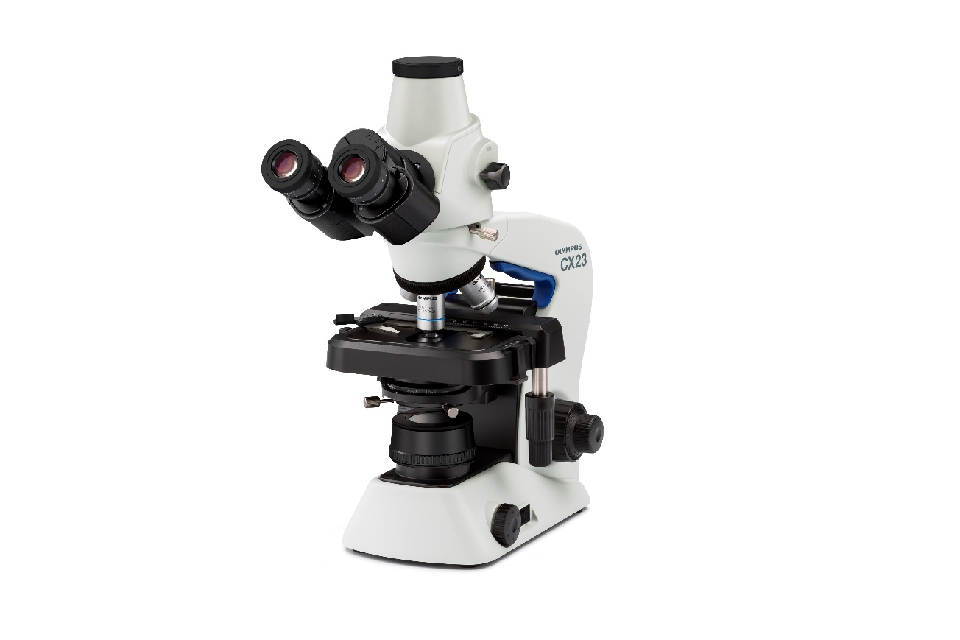
\

Olympus’ CX23 Trinocular microscopes will help you visualise and capture your samples with precise detail, vibrant colours and high resolution.

The New Olympus CX23 Trinocular microscopes offers high optical performance with large field number of 20, a built-in LED light source that provides uniform and stable illumination with low power consumption and an ergonomic design for easy and safe operation.

The CX23 Trinocular microscope can be coupled with a range of cameras that will enable capturing high resolution images faster and easier.

